**ST. XAVIER’S COLLEGE**

**(Affiliated to Tribhuvan University)**

Maitighar, Kathmandu



**COMPUTER GRAPHICS**

**LAB ASSIGNMENT #05**

**Submitted by:**

Rojesh Tamrakar

013BSCCSIT032

**Submitted to:**

|  |  |
| --- | --- |
| **Er. Anil K. Sah** |  |

Lecturer

Department of Computer Science

Date of submission: 21th August, 2015

# STATEMENT: To implement the mid-point circle algorithm to draw a circle:

# ALGORITHM:

# 1. Input the radius and circle centre(xc,yc) and obtain the first point on circle centers at origin as

# (X0, y0)= (0, r).

# 2. Calculate initial decision parameter

# P0=5/4-r

# 3. At each x, position starting at k=0 perform the tests

# If p0<0 next point along the circle centre at (0, 0) is (xk+1,yk)

# Pk+1=pk+2xk+1+1)

# Otherwise the next point along circle is (xk+1,yk-1)

# Pk+1=pk+2xk+1+1-2yk-1

# 4. Determine symmetry point on the other seven octants

# 5. Move each calculated pixels positions (x,y) in to circle path centered at (xc,yc) as

# x=x+xc

# y=y+yc

# 6. Repeat 3 through 5 until x>=y.

# SOURCE CODE:

# #include <vcl\vcl.h>

# #pragma hdrstop

# #include "Unit1.h"

# //---------------------------------------------------------------------------

# #pragma resource "*.dfm"

# TForm1 *Form1;

# int xc,yc,r;

# int x,y,p;

# //---------------------------------------------------------------------------

# __fastcall TForm1::TForm1(TComponent* Owner)

# : TForm(Owner)

# {

# }

# //---------------------------------------------------------------------------

# void __fastcall TForm1::Button1Click(TObject *Sender)

# {

# xc=StrToInt(Edit1->Text);

# yc=StrToInt(Edit2->Text);

# r=StrToInt(Edit3->Text);

# x=0;

# y=r;

# Image1->Canvas->Pixels[xc+x][yc+y]=RGB(255,10,10);

# Image1->Canvas->Pixels[xc-x][yc+y]=RGB(10,255,10);

# Image1->Canvas->Pixels[xc+x][yc-y]=RGB(10,10,255);

# Image1->Canvas->Pixels[xc-x][yc-y]=RGB(255,255,0);

# Image1->Canvas->Pixels[xc+y][yc+x]=RGB(10,255,255);

# Image1->Canvas->Pixels[xc-y][yc+x]=RGB(255,10,255);

# Image1->Canvas->Pixels[xc+y][yc-x]=RGB(100,100,100);

# Image1->Canvas->Pixels[xc-y][yc-x]=RGB(200,200,200);

# p=1-r;

# while(x<y)

# {

# if(p<0)

# {

# x=x+1;

# p=p+2*x+1;

# }

# else

# {

# x=x+1;

# y=y-1;

# p=p+2*(x-y)+1;

# }

# Image1->Canvas->Pixels[xc+x][yc+y]=RGB(255,10,10);

# Image1->Canvas->Pixels[xc-x][yc+y]=RGB(10,255,10);

# Image1->Canvas->Pixels[xc+x][yc-y]=RGB(10,10,255);

# Image1->Canvas->Pixels[xc-x][yc-y]=RGB(255,255,10);

# Image1->Canvas->Pixels[xc+y][yc+x]=RGB(10,255,255);

# Image1->Canvas->Pixels[xc-y][yc+x]=RGB(255,10,255);

# Image1->Canvas->Pixels[xc+y][yc-x]=RGB(100,100,100);

# Image1->Canvas->Pixels[xc-y][yc-x]=RGB(200,200,200);

# }

# }

# //---------------------------------------------------------------------------

# OUTPUT

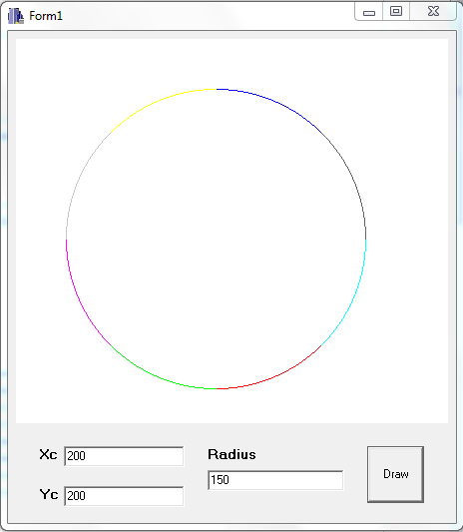

# CONCLUSION:

Hence, the mid-point circle algorithm was implemented using C++ builder. The mid-point circle algorithm helped to draw the circle by entering the radius and center.